New Mahindra Scorpio-N Facelift: Price, Specifications, Features & Complete Review

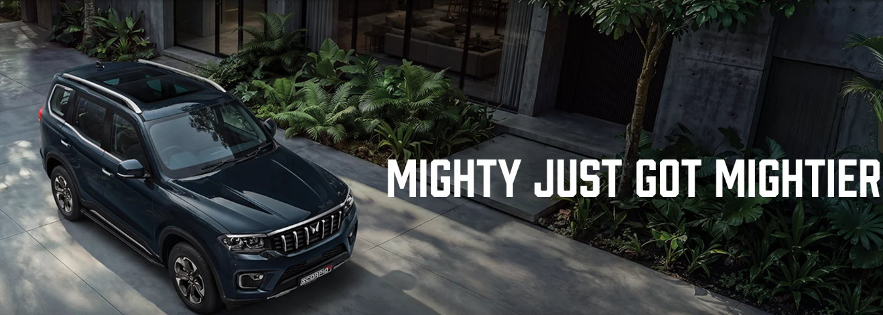
Few names in the Indian SUV market command as much respect on the road as the Mahindra Scorpio. Ever since the original Scorpio-N rolled in and re-wrote what buyers expected from a home-grown body-on-frame SUV, it has worn its self-given "Big Daddy of SUVs" title with genuine confidence. Now, Mahindra has gone back to the drawing board to sharpen that dominance even further with the new Scorpio-N facelift. The 2026 update isn't a ground-up reinvention — it doesn't need to be — but it brings in a Panoramic Skyroof, richer cabin materials, a longer features list, and a handful of thoughtful engineering tweaks that make an already formidable SUV feel even more complete.
In this article, BikeCarHub takes a deep dive into everything the new Scorpio-N facelift brings to the table — its price in India, exterior and interior updates, engine and transmission options, technology, safety suite, variants, colours, and a full specification breakdown. Whether someone is comparing this SUV against its rivals or simply curious about what's changed, this guide from BikeCarHub is meant to be the one-stop reference before making a decision at the dealership.
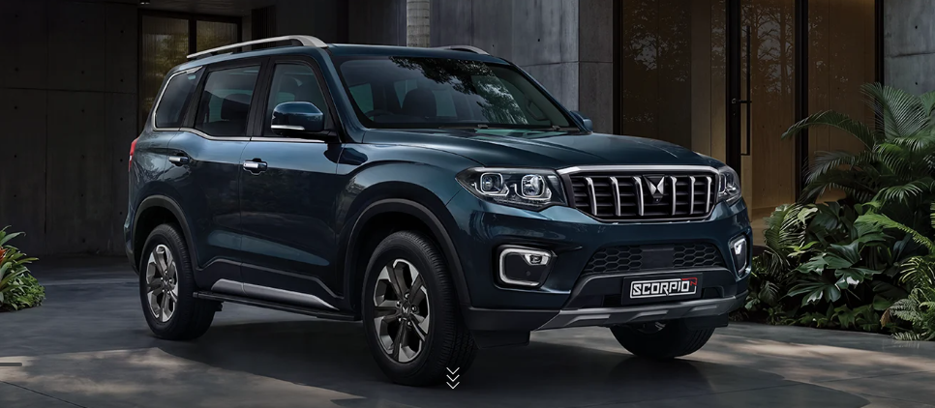

New Scorpio-N Facelift: Price in India
The Mahindra Scorpio-N facelift is offered at an ex-showroom price ranging from ₹13.69 Lakh to ₹25.49 Lakh, depending on the variant, engine, transmission, and drivetrain a buyer picks. This wide price band is one of the biggest strengths of the Scorpio-N line-up, because it allows the SUV to compete with both mid-range family SUVs as well as premium, feature-loaded ones under the same nameplate.
At the entry level, buyers get the no-nonsense Z2 trim that focuses on the core Scorpio-N experience — the road presence, the body-on-frame toughness, and dependable engines — without the frills. Move up the ladder to the Z8L and Z8L six-seater trims, and the price climbs to reflect a nearly loaded feature set that includes a panoramic skyroof, ventilated seats, a 12-speaker Sony sound system, Level 2 ADAS, and a full 540-degree camera suite. Because pricing can vary slightly by state due to road tax and registration charges, BikeCarHub always recommends checking with the nearest Mahindra dealership for the final on-road price before booking.

Exterior Design: Still the Big Daddy of SUVs
Mahindra hasn't messed with a winning formula on the outside, and that's a good thing. The Scorpio-N facelift retains its towering, larger-than-life silhouette, but sharpens several details that make the face and profile look even more premium in person.

Signature Double-Barrel LED Headlamps
Right up front, the SUV continues with its now-iconic double-barrel LED projector headlamps. These are flanked by sting-like LED daytime running lamps that wrap around the fog lamp housing, giving the face a distinctive, unmistakable identity even at a glance in the rear-view mirror of the car ahead.
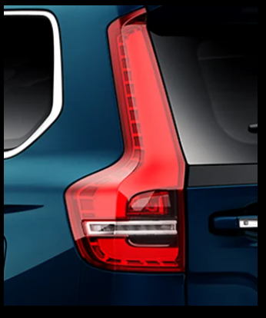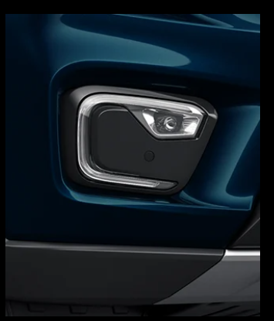
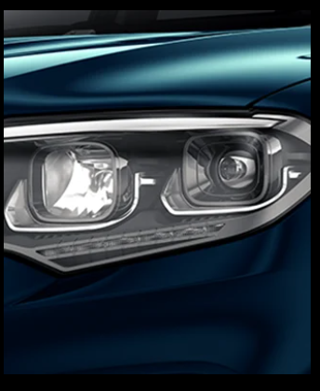

A Bolder, Wider Front Face
The full-width front grille has been finished with premium chrome accents and is framed by rugged protective cladding, which not only looks butch but also hints at the SUV's genuine off-road intent. Sequential LED turn indicators on the ORVMs add a touch of modern sophistication to what is otherwise a very muscular design language.
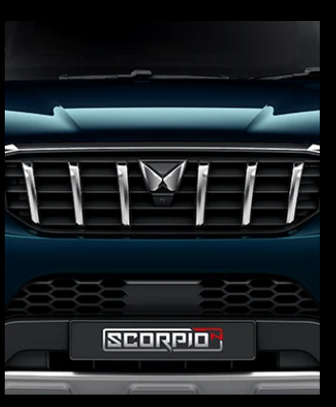

Stance, Wheels & Proportions
The lofty shoulder line and high-set sculpted bonnet continue to give the driver a commanding view of the road, while the newly redesigned R18 diamond-cut alloy wheels fill out the wheel arches nicely on the top-spec trims. Roof rails, a silver-finished ski rack (on select trims), and a signature metallic Scorpio-tail design element at the rear round off a look that's built to turn heads without trying too hard.
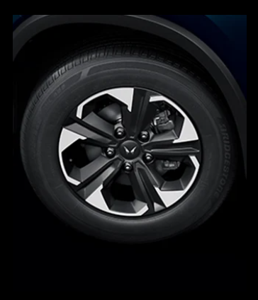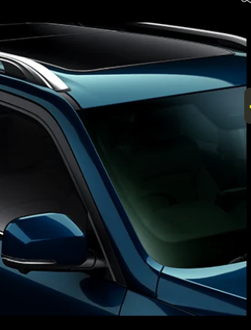

Interior & Cabin Comfort
Step inside, and the new Scorpio-N facelift makes a strong case for being one of the most premium cabins in its segment. Mahindra has clearly worked on making the interior feel as commanding as the exterior suggests.

Panoramic Skyroof
The biggest interior addition is the Panoramic Skyroof, available on the higher trims, which floods the cabin with natural light and gives second-row passengers a genuinely open, airy feel that was missing from a conventional sunroof. It adds a new sense of grandeur to what was already a spacious cabin.

Premium Materials
The dashboard gets a leather-wrapped treatment braced by dual metal-finished rails, and the seats are upholstered in a rich coffee-black leatherette that feels genuinely upmarket. Every touchpoint, from the gear shifter to the steering wheel, has been designed to reinforce that sense of "seat of power" comfort Mahindra keeps talking about in its marketing for this SUV.

Seating, Comfort & Practicality
The Scorpio-N facelift continues to be offered in both 6-seater and 7-seater configurations, with wide, body-hugging seats and strong thigh support designed to make long journeys feel shorter. The driver gets a 6-way power-adjustable seat with lumbar support, so finding that ideal driving position takes seconds rather than minutes. Both front seats also come with ventilation, a genuinely welcome feature for Indian summers, keeping occupants cool regardless of the outside temperature.
On the practicality side, boot space stands at a healthy 786 litres with the third row folded flat, which is more than enough for a family's luggage on a long road trip. Climate control duties are handled by a Dual-zone Fully Automatic Temperature Control system up front, while dynamic rear AC vents ensure even second and third-row passengers stay comfortable.
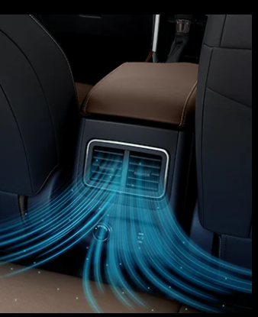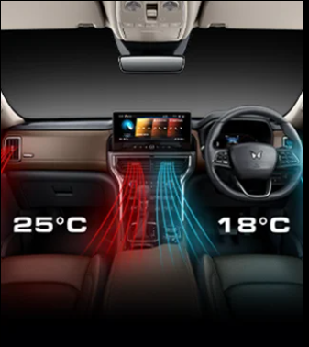

Technology & Infotainment Features
Mahindra has packed the Scorpio-N facelift with a genuinely modern technology suite, and this is one area where the SUV feels like it's punching well above its price point.

Big Screens for the Big Daddy
The cabin is dominated by a large 31.24 cm (about 12.3-inch) HD touchscreen infotainment system paired with a crystal-clear 26.03 cm HD digital instrument cluster on the top trims. Powered by the Qualcomm 6155 chipset and Mahindra's own Adrenox cockpit controller, the system feels quick to respond and doesn't lag when switching between apps, navigation, and camera views.
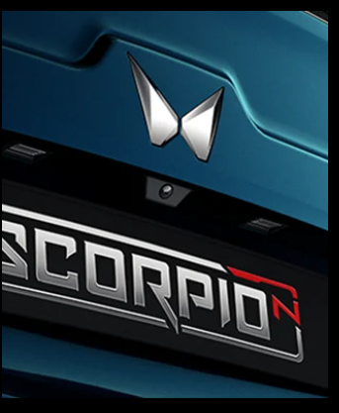

Adrenox Connect & Alexa Built-in
Owners get access to more than 70 connected car features through the Adrenox Connect smartphone app, covering everything from remote engine start and climate control to geo-fencing, window control, and skyroof operation from a distance. Built-in Alexa voice control also means the cabin genuinely responds to spoken commands, whether it's adjusting the temperature or making a call.
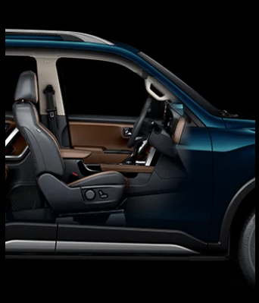

540-Degree Surround View Camera
A four-camera setup creates a full 540-degree surround view in both 2D and 3D, essentially removing blind spots when manoeuvring in tight parking spaces or navigating narrow lanes.

Audio, Charging & Connectivity
Music lovers are treated to a custom-engineered 12-speaker Sony sound system with a dual-channel subwoofer that delivers a genuinely immersive, 3D-like audio experience inside the cabin. Practical touches include a wireless charging pad with active cooling that prevents phones from overheating during long charging sessions, along with Type-C fast charging ports for both front and rear rows. Android Auto and Apple CarPlay support, both wired and wireless depending on variant, ensure smartphone connectivity is never a hassle.

Engine, Performance & Transmission Options
Under the hood, the new Scorpio-N facelift continues with the same tried-and-tested engine line-up that has powered the model since launch, and that's largely a good thing given how well-regarded these engines already are in the segment.

mStallion Turbo Petrol Engine
The petrol option is the 2.0-litre mStallion Turbocharged Gasoline Direct Injection (TGDi) engine, which produces 149.14 kW of power along with 370 Nm of torque on the manual gearbox and 380 Nm on the automatic. It's a refined, punchy engine that feels eager through the rev range and suits buyers who primarily drive in city and highway conditions.

mHawk Diesel Engine
On the diesel side, the Scorpio-N facelift uses the 2.2-litre mHawk engine with Common Rail Direct Injection technology. The higher state of tune produces 128.6 kW of power with 370 Nm of torque on the manual and 400 Nm on the automatic, while a lower-power variant available on select 2WD manual trims produces 97 kW with 300 Nm of torque. This gives buyers real flexibility depending on whether they prioritise outright grunt or a slightly more accessible price point.

Transmission & Drive Modes
Both engines can be paired with either a 6-speed manual or a 6-speed automatic transmission, and Mahindra says every transmission uses segment-first, shift-by-cable technology for cleaner, more precise gear changes. Diesel variants also get the brand's Zip-Zap-Zoom drive modes — Zip for smooth, easy city driving, Zap for a more spirited, true SUV character, and Zoom for maximum engagement and response.
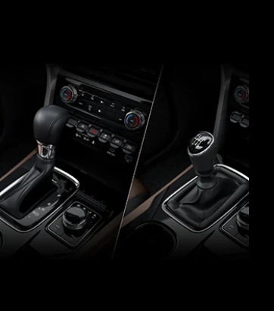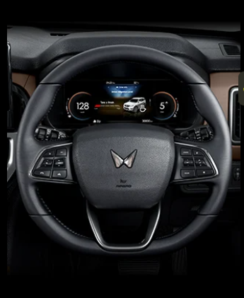

Drivetrain Options
The Scorpio-N facelift is built on a rear-wheel-drive platform by default, which Mahindra says gives the SUV more torque and authority on the move. For buyers who need genuine off-road capability, a selectable shift-on-fly 4WD system is available on diesel variants, complete with the 4XPLOR intelligent terrain management system offering Normal, Snow, Mud & Ruts, and Sand modes, along with dedicated 4-High and 4-Low gear ranges.

Ride, Handling & Suspension
A big, heavy body-on-frame SUV is only as good as the chassis and suspension holding it together, and this is another area where the Scorpio-N facelift has genuinely moved the needle.
The SUV rides on a next-generation 3G frame that has been engineered from scratch using high-strength steel throughout, giving the entire platform a noticeably stiffer, more planted feel. At the front, a Double Wishbone suspension setup with coil-over shocks does duty, while the rear uses a category-first Penta Link suspension featuring WATT's Linkage. Both ends benefit from Frequency Dependent Damping (FDD) and advanced shock absorbers, which are tuned to quietly absorb harsh road impacts before they ever reach the cabin.
Steering duties are handled by an electric power steering system that Mahindra has tuned to stay light enough for tight city lanes while remaining precise through fast mountain curves. An Advanced Electronic Brake Locking Differential also steps in automatically the moment a wheel loses traction, electronically locking things down so the vehicle stays composed even on slippery surfaces.
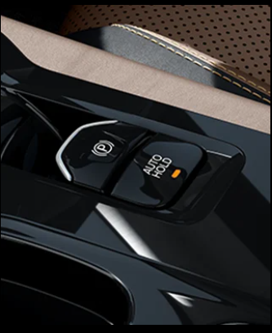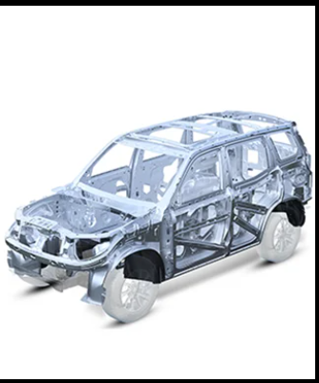

Safety Features & Level 2 ADAS
Mahindra has always positioned safety as a core pillar of the Scorpio-N, and the facelift continues that trend with a genuinely comprehensive suite of both passive and active safety features.

Passive Safety Highlights
- Up to 6 airbags covering front, side, and curtain zones on higher trims
- Electronic Stability Control (ESC) suite with 18 individual features
- ABS with EBD and all-wheel ventilated disc brakes
- Hill Hold Control and Hill Descent Control for steep gradients
- ISOFIX / i-SIZE child seat mounting points
- Tyre Pressure Monitoring System (TPMS)
- Auto-Dimming Interior Rear-View Mirror
- 3-point seatbelts with pretensioners and reminders for all occupants
- SOS emergency switch with automatic crash detection connected to Mahindra's With You Hamesha assistance network

Level 2 ADAS Suite
On the AT variants, the Scorpio-N facelift is available with a genuine Level 2 Advanced Driver Assistance System, positioning it as one of the more tech-forward options in its price bracket.
- Automatic Emergency Braking (AEB) for vehicles, pedestrians and cyclists
- Forward Collision Warning
- Adaptive Cruise Control with Stop & Go
- Smart Pilot Assist that manages steering, acceleration and braking together
- Lane Departure Warning and Lane Keep Assist
- Traffic Sign Recognition and Speed Limit Assist
- High Beam Assist and Front Vehicle Start Alert
Mahindra is clear that these ADAS features are designed to assist the driver and are not a replacement for an attentive human behind the wheel — the driver remains fully responsible for safe driving at all times.

Variants, Seating Configurations & Colour Options
The Scorpio-N facelift line-up spans seven trims — Z2, Z4, Z6, Z8S, Z8, Z8T, and Z8L — with the Z8L also available in a dedicated 6-seater captain-seat layout for buyers who prefer a more premium, lounge-like second row over outright seating capacity.
On the colour front, buyers can choose from five shades: Deep Forest, Everest White, Galaxy Grey, Oceanic, and Stealth Black, each of which brings out the SUV's muscular body lines a little differently depending on the lighting.

Full Specifications: Mahindra Scorpio-N Facelift
Specification | Petrol (mStallion TGDi) | Diesel (mHawk CRDe)
Engine Capacity | 2.0 L Turbo Petrol | 2.2 L Diesel
Max Power | 149.14 kW @ 5000 rpm | 128.6 kW @ 3500 rpm / 97 kW @ 3750 rpm*
Max Torque (MT) | 370 Nm @ 1750-3000 rpm | 370 Nm @ 1500-3000 rpm / 300 Nm @ 1600-2800 rpm*
Max Torque (AT) | 380 Nm @ 1750-3000 rpm | 400 Nm @ 1750-2750 rpm
Transmission | 6-Speed MT / 6-Speed AT | 6-Speed MT / 6-Speed AT
Drivetrain | RWD | RWD / 4WD (selectable)

*97 kW / 300 Nm diesel state of tune is available only on Z2 and Z4 trims with 2WD manual transmission.
Dimension / Feature | Details
Length x Width x Height | 4662 mm x 1917 mm x 1857 mm (without ski rack & antenna)
Wheelbase | 2750 mm
Front Suspension | Double Wishbone with Coil-over Shocks, FDD & MTV-CL
Rear Suspension | Pentalink with WATT's Linkage, FDD & MTV-CL
Brakes | Ventilated Disc, Front & Rear
Fuel Tank Capacity | 57 Litres
Boot Space (3rd row folded) | 786 Litres
Alloy Wheels | R18 Diamond Cut (Z8T, Z8L) / R17 Diamond Cut (Z8S, Z8)
Infotainment Screen | Up to 31.24 cm HD Touchscreen
Digital Cluster | Up to 26.03 cm HD Display
Sound System | 12-Speaker Sony 3D Immersive Audio

Variant-wise Feature Comparison
To make cross-shopping easier, BikeCarHub has put together a quick variant comparison covering the most important features buyers typically look for while choosing between Scorpio-N trims.
Feature | Z2 / Z4 / Z6 | Z8S / Z8 | Z8T / Z8L
Seating Capacity | 7-Seater | 7-Seater | 7-Seater / 6-Seater (Z8L)
Sunroof | Not Available | Not Available | Panoramic Skyroof (Z8L) / Sunroof (Z8T)
Infotainment | 22.86 cm / Not on Z2 | 20.32 cm | 31.24 cm HD
Digital Cluster | 10.66 cm Monochrome | 10.66 cm Monochrome | 26.03 cm HD
ADAS (Level 2) | Not Available | Not Available | Available (AT variants)
Ventilated Seats | Not Available | Not Available | Available
Alloy Wheels | Steel (Z2/Z4/Z6) | R17 Diamond Cut Alloy | R18 Diamond Cut Alloy
4WD Option | Available on Z4 (Diesel) | Not Available | Available (Diesel)
Airbags | Front (2) | 6 Airbags (Front+Side+Curtain) | 6 Airbags (Front+Side+Curtain)
Wireless Charger | Not Available | Available (higher trims) | Available

Why the Scorpio-N Facelift Still Stands Out — BikeCarHub's Take
The Indian mid-size and full-size SUV segment has become intensely competitive, but the Scorpio-N facelift continues to carve its own space by leaning into exactly what made the nameplate popular in the first place: unmatched road presence, genuine body-on-frame ruggedness, and a feature list that punches above its price. The addition of the Panoramic Skyroof, refreshed cabin materials, and a more comprehensive Level 2 ADAS suite means the facelift isn't just a cosmetic refresh — it addresses some of the real gaps buyers had pointed out in the outgoing model.
For families that want a genuinely capable SUV that can double up as a comfortable daily driver and a weekend off-roader, the Scorpio-N facelift remains one of the most compelling options in its price range. The team at BikeCarHub believes that buyers cross-shopping this segment should pay close attention to the mid and top variants (Z8, Z8T, Z8L), since that's where the SUV's true value proposition — ADAS, panoramic skyroof, and the full safety suite — really comes alive.

Conclusion
The new Mahindra Scorpio-N facelift builds on an already winning formula by adding genuine value in the areas that matter most — comfort, technology, and safety — without losing the muscular character that made the original such a runaway success. With a wide price range starting at ₹13.69 Lakh, multiple engine and drivetrain choices, and a feature list that now includes a Panoramic Skyroof and Level 2 ADAS, the Scorpio-N facelift continues to justify its self-proclaimed title as the Big Daddy of SUVs. For anyone shopping in this segment, BikeCarHub recommends a test drive before finalising a decision, since numbers on paper rarely capture just how commanding this SUV feels from behind the wheel.

Frequently Asked Questions

1. What is the price of the new Mahindra Scorpio-N facelift?
The Mahindra Scorpio-N facelift is priced between ₹13.69 Lakh and ₹25.49 Lakh (ex-showroom), depending on the variant, engine, transmission, and drivetrain selected.

2. What engine options are available on the Scorpio-N facelift?
Buyers can choose between a 2.0-litre mStallion turbo petrol engine producing 149.14 kW of power, or a 2.2-litre mHawk diesel engine available in two states of tune — 128.6 kW and 97 kW — depending on the variant selected.

3. Does the Scorpio-N facelift get a sunroof?
Yes. The top-spec Z8L variant gets a Panoramic Skyroof, while the Z8T trim comes with a conventional sunroof. Lower variants do not offer a sunroof or skyroof.

4. Is 4WD available on the new Scorpio-N facelift?
Yes, a selectable shift-on-fly 4WD system paired with the 4XPLOR intelligent terrain management system is available on select diesel variants, including the Z4 and the Z8T/Z8L trims.

5. How many airbags does the Scorpio-N facelift offer?
Entry-level trims come with 2 front airbags, while the Z8S trim and above are equipped with 6 airbags covering the front, side, and curtain zones for all-round occupant protection.

6. Does the Scorpio-N facelift get ADAS features?
Yes, the Scorpio-N facelift offers a Level 2 ADAS suite on automatic transmission variants, including Automatic Emergency Braking, Adaptive Cruise Control with Stop & Go, Lane Keep Assist, Smart Pilot Assist, and Traffic Sign Recognition, among other features.

7. What is the boot space of the Scorpio-N facelift?
With the third row of seats folded down, the Scorpio-N facelift offers 786 litres of boot space, making it a genuinely practical option for long family road trips.

8. Is the Scorpio-N facelift available in a 6-seater configuration?
Yes, alongside the standard 7-seater layout, Mahindra offers a dedicated 6-seater captain-seat configuration on the top-spec Z8L variant.

9. What colours are available on the new Scorpio-N facelift?
The Scorpio-N facelift is offered in five colour options: Deep Forest, Everest White, Galaxy Grey, Oceanic, and Stealth Black.

10. What is the fuel tank capacity of the Scorpio-N facelift?
The Mahindra Scorpio-N facelift comes with a 57-litre fuel tank across both the petrol and diesel variants.

SEO Metadata
Title Tag: Mahindra Scorpio-N Facelift 2026 Price & Specs
Meta Description: Explore the new Mahindra Scorpio-N facelift's price, specs, engine, features, ADAS & variants. Full review with FAQs by BikeCarHub.
Keywords: Scorpio-N facelift, new Scorpio-N price, Mahindra Scorpio-N 2026, Scorpio-N specifications, Scorpio-N ADAS, Scorpio-N mileage, Scorpio-N variants, Scorpio-N colours, Scorpio-N vs rivals, Big Daddy of SUVs, Mahindra Scorpio-N review, Scorpio-N diesel petrol engine

